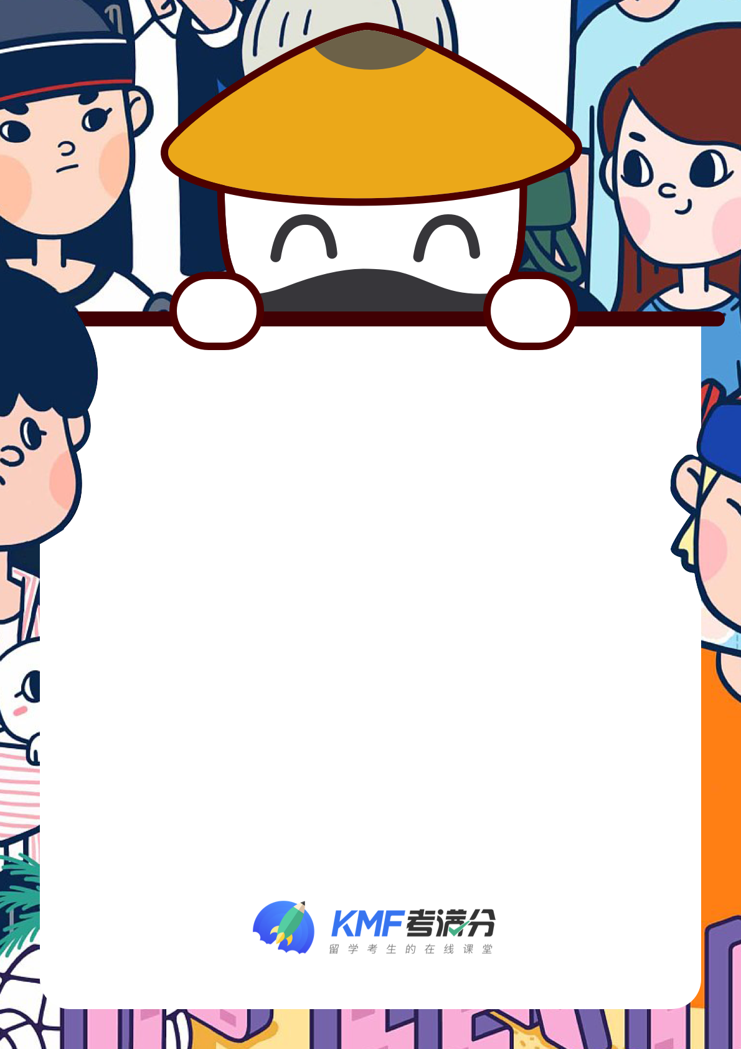

老师：董慧女

IELTS 写作修改

资料内容版权归 考满分 所有，私自转载使用追究法律责任

The line graph illustrates the electricity consumption in England in a typically whole day in winter and summer respectively, while the pie chart focuses on ~~the proportion analysis of~~ average electricity consumption for different usage\usages in an English home.

Overall, according to the two figures\figures above, the electricity consumption in winter is nearly twice that in summer for a whole day, and an average English home spends the highest percentage 添加主题词of electricity on heating rooms and heating water, which is more than half of the electricity consumption.

To be more specific, the electricity consumption in winter increases gradually from 32,000 at 0 AM to 40,000 at 3 AM and then bottoms out 谷值是特殊值，应该点出数据 at the whole day at 7 o'clock. From then on, it experiences a slow increase in the following hours, reaching a maximum 峰值是特殊值，应该点出数据 of at 11 PM, after which it drops sharply in the later hour. Interestingly, the figure of\for 固定搭配 summer shows a different tendency comparing with that of\for winter. It declines slightly during the first nine hours and then surges to the peak of the whole day峰值是特殊值，应该点出数据 at at 2 PM, and 可数名词用冠词修饰 a fluctuation was\is 全文时态一致 found clearly since then.

When it comes to the proportion, heating rooms and water, is second to none, which use 52.5% alone, closely followed by Ovens, kettles, and washing machines, which is only less than one in third of the former表意不明，比较数据放在less than 前. After that, the rest of the percentage(about 30%) is shared evenly by the two other items.

小作文 ​总分：6.5

TA: 7

CC: 7

LR: 6

GRA:6

逻辑层面：全文对于总体趋势的描述比较合理，但注意动态数据中的趋势可以再多样一些，句型也可以再多样点，拟人句，被动句，介词短语做表语等~且趋势段之间的连接手段除了时间上的然后，还可以再多样一些，可以积累一些上课讲过的复杂连接词~静态数据的引入方式可以尝试差值比较或者分数倍数比较~

语法层面：注意语法准确性，尤其是一些固定搭配不要记错了呀~加油，把语法错误控制在0个，GRA就可以上7分了哦~

1.1 The line graph illustrates the electricity consumption in England in a typically whole day in winter and summer respectively, while the pie chart focuses on the proportion analysis of average electricity consumption for different usage in an English home. [搭配错误]搭配 illustrate consumption在语料库中无此用法，疑似中式英语。

[搭配警示]the proportion analysis疑似中式英语。

[推荐表达]entire与whole意思相近，可参考学习。

[拓展辨析]查看respectively与respectful的区别。

[推荐表达]emphasize/highlight/attach importance to/give priority to与focuses on意思相近，可参考学习。

第1段

2.1 Overall, according to the two figures above, the electricity consumption in winter is nearly twice that in summer for a whole day, and an average English home spends the highest percentage on heating rooms and heating water, which is more than half of the electricity consumption. [推荐表达]entire与whole意思相近，可参考学习。

[近义词表达学习]according to在做“根据”讲时，近义表达有in accordance with。

[推荐表达]next to与nearly意思相近，可参考学习。

第2段

3.1 To be more specific, the electricity consumption in winter increases gradually from 32,000 at 0 AM to 40,000 at 3 AM and then bottoms out the whole day at 7 o'clock. [推荐表达]entire与whole意思相近，可参考学习。

[学习提示]易混词汇: concrete, specific 均含“具体的”之意。

[推荐表达]subsequently/afterward/thereafter/after that/succeeding/secondarily/what is more/furthermore与then意思相近，可参考学习。

3.2 From then on, it experiences a slow increase in the following hours, reaching a maximum at 11 PM, after which it drops sharply in the later hour. [拓展辨析]动名搭配 experience...increase 在语料库中出现过 42 次

3.3 Interestingly, the figure of summer shows a different tendency comparing with that of winter. [拓展辨析]动名搭配 show...tendency 在语料库中出现过 48 次

3.4 It declines slightly during the first nine hours and then surges to the peak of the whole day at 2 PM, and fluctuation was found clearly since then. [拓展辨析]查看clearly与clear的区别。

[推荐表达]subsequently/afterward/thereafter/after that/succeeding/secondarily/what is more/furthermore与then意思相近，可参考学习。

[推荐表达]entire与whole意思相近，可参考学习。

[推荐表达]in the course of与during意思相近，可参考学习。

[推荐表达]subsequently/afterward/thereafter/after that/succeeding/secondarily/what is more/furthermore与then意思相近，可参考学习。

第3段

4.1 When it comes to the proportion, heating rooms and water, is second to none, which use 52.5% alone, closely followed by Ovens, kettles, and washing machines, which is only less than one in third of the former. [精彩句型]When it comes to用得巧妙，作文容易出彩。

[推荐表达]just/merely/barely/singly/solely/rarely与only意思相近，可参考学习。

[学习提示]易混词汇: percent, percentage 均可表示“百分比”之意。

4.2 After that, the rest of the percentage(about 30%) is shared evenly by the two other items. [学习提示]易混词汇: share, participate 均含有“分享，分担”之意。



- END -

资料内容版权归 考满分 所有，私自转载使用追究法律责任